Single jacket multitube self-supporting aerial cable AERO AS04

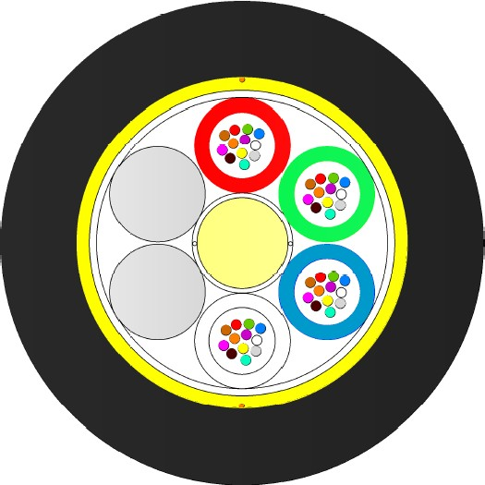PE sheath Aramid yarns filling compound
Central strength member (FRP) Loose tubes (PBT)
Water blocking yarns Fillers (if applicable) Optical fibers Water blocking tape

*schematic drawing, not to scale
Ripcord

APPLICATION: DESIGN:

For installation on poles or in ducts. Fully dielectric cable
Self-supporting aerial cable with aramid reinforcement
For installation along power lines with an operation voltage below 150 kV and producing space potential below 4 kV.
FRP strength and anti-buckling element Dry yarns to prevent moisture into the cable
Loose tube (PBT Ø 2.0mm) with filing compound 6-24 elements SZ stranded cable core
Optical fibres
Fillers (if applicable) Water-swellable tape
Aramid yarns as strain relief and water absorbent

UV stabilized PE sheath

CABLE DESIGNS:
Variant | Quantity [pcs] |  |  |  | Ø nominal (±5%) | Nominal  weight (±10%) | Max  allowed tension | Max  static tension
 | Fibres | Fibres per tube | Total elements | Active tubes
 |  |  |  |  | [mm] | [kg/km] | [N] | [N]
1-6T x 6F | 6-36 | 6 | 6 | 1-6 | 10,1 | 76 | 4100 | 2400
1-6T x 8F | 8-48 | 8 | 6 | 1-6 | 10,1 | 78 | 4100 | 2400
1-6T x 12F | 12-72 | 12 | 6 | 1-6 | 10,1 | 82 | 4000 | 2000
8T x 6F | 48 | 6 | 8 | 8 | 11.3 | 98 | 4200 | 2500
8T x 12F | 96 | 12 | 8 | 8 | 11,4 | 103 | 4200 | 2100
12T x 12F | 144 | 12 | 12 | 12 | 13,9 | 149 | 4100 | 2000
16-18T x12F | 192 - 216 | 12 | 18 | 16-18 | 14,5 | 152 | 4000 | 1800
20-24T x 12F | 240 - 288 | 12 | 24 | 20-24 | 16,4 | 197 | 4100 | 2000
Other fibre counts available on demand

MECHANICAL AND ENVIRONMENTAL CHARACTERISTICS

Crush performance: 2000 [N/10 cm] IEC 60794-1-21-E3, Δα≤0,05 dB, reversible

Bending radius: Static: 15 x D
 | Dynamic: 20 x D | IEC 60794-1-21-E6, Δα≤0,05 dB, reversible
Water penetration: | 3[m] sample, 1[m] head, 24[h] | IEC 60794-1-22-F5, no leakage
Temperature range  Installation: | -15... +55 [°C] | IEC 60794-1-22-F1, Δα≤0,05 dB/km
Operation:  Transport & Storage: | -40… +70 [°C]  -40… +70 [°C]

APPLICATION AND CABLE SPAN CHARACTERISTIC
6 tubes design:
Loading Conditions | Span | Installed Sag (2%) | Tension | Total sag | Horizontal sag | Vertical sag
 | [m] | [m] | [N] | [m] | [m] | [m]
NSC Light NSC Medium  NSC Heavy | 250 | 5,0 | 4000 | 10,6 | 10,2 | 3,1
 | 170 | 3,4 | 4000 | 7,6 | 4,8 | 6,0
 | 95 | 1,9 | 4000 | 4,5 | 2,3 | 3,9

8 tubes design:
Loading Conditions | Span | Installed Sag (2%) | Tension | Total sag | Horizontal sag | Vertical sag
 | [m] | [m] | [N] | [m] | [m] | [m]
NSC Light NSC Medium  NSC Heavy | 220 | 4,4 | 4100 | 8,9 | 8,6 | 2,6
 | 160 | 3,2 | 4100 | 6,9 | 4,3 | 5,5
 | 90 | 1,8 | 4100 | 4,1 | 2,1 | 3,5

12 tubes design:
Loading Conditions | Span | Installed Sag (2%) | Tension | Total sag | Horizontal sag | Vertical sag
 | [m] | [m] | [N] | [m] | [m] | [m]
NSC Light NSC Medium  NSC Heavy | 175 | 3,5 | 4100 | 6,9 | 6,6 | 2,2
 | 135 | 2,7 | 4000 | 5,7 | 3,4 | 4,5
 | 80 | 1,9 | 4000 | 3,6 | 1,8 | 3,1

18 tubes design:
Loading Conditions | Span | Installed Sag (2%) | Tension | Total sag | Horizontal sag | Vertical sag
 | [m] | [m] | [N] | [m] | [m] | [m]
NSC Light NSC Medium  NSC Heavy | 160 | 3,2 | 4000 | 6,1 | 5,8 | 2,0
 | 130 | 2,6 | 4000 | 5,3 | 3,1 | 4,3
 | 75 | 1,5 | 4000 | 3,5 | 1,7 | 3,1

24 tubes design:
Loading Conditions | Span | Installed Sag (2%) | Tension | Total sag | Horizontal sag | Vertical sag
 | [m] | [m] | [N] | [m] | [m] | [m]
NSC Light NSC Medium NSC Heavy | 150 | 3.0 | 4100 | 5.9 | 5.5 | 1.9
 | 125 | 2.5 | 4100 | 5.2 | 3.1 | 4.2
 | 75 | 1.5 | 4100 | 3.3 | 1.6 | 2.9

OPTICAL FIBRE AND LOOSE TUBES COLOUR IDENTIFICATION
For optical fibres and loose tube identification information please see DSH_Colors_CODE_XXXX document.

FIBRE PARAMETERS
For selected post-production optical fibres parameters please see DSH_OFP document.

MARKING
The following print (white / hot foil) is applied at 1-meter intervals:
- Supplier: FIBRAIN
- Standard code (Product type, fibre type, fibre count)
- Year of manufacture: xxxx
- Length marking in meters
- Cable ID / Drum No

Example: FIBRAIN AERO AS04 T20 12F SM G652D 2T6F “YEAR OF MANUFACTURE” “LASER SYMBOL” “LENGTH MARKING” “BATCH NUMBER”

The accuracy of marking is ±0,5%. Remarking is in accordance with Bellcore GR 20 and supersedes earlier markings. Occasional loss of marking is possible. Cables can be supplied with a range of single mode or multimode fibres and customized print.

PACKING
Cables will be shipped on disposable wooden or treated wooden drums. Both ends of the cable will be capped and accessible for testing. Rotation direction arrow will be marked on the drum together with identification information.

DELIVERY LENGTH
2000 – 8000 meters ± 5%, with possibility of supplying up to 5% of total contract quantity as short length cables which should be above 1000 meters long. Tolerance of 5 % of order quantity shall be allowed.

This document and the statements contained in it are not intended for customers within the meaning of the Civil Code. The information submitted in this document is to our knowledge and belief true at the time of issue, however, we do not assume any liability whatsoever for its accuracy, and completeness. This document is for informational purposes on an “as is” basis only and Fibrain reserves the right to change its contents at any time without prior notice. The specification cannot, in any case, be considered an offer within the meaning of the Civil Code and is not contractually valid unless specifically authorized by Fibrain. Before using this product, its buyer and/or user has to make sure that it is suitable for the intended use. All liability issues related to this product are subjected to the seller’s separate Terms of Sale or the terms and conditions agreed with the Fibrain representative or distributor.

